ST.FRANCIS XAVIER MODERN SECONDARY SCHOOL.

Uganda Certificate of Lower Secondary Curriculum.

S.1 Physics end of Term one Assessments, 2024.

Time: 1 hour 15 minutes.

INSTRUCTIONS:

* All questions are compulsory
* All questions carry equal marks.

Item one:

Akello was a young girl, about six years old. She enjoyed listening to her parent’s radio .whenever a nice song played, she would get up and dance. But she always wondered how the people managed to fit inside such a small radio in her parents’ bedroom. One day, her parents did not lock their bed room as they left for work. This is my opportunity to open this radio and see the people that talk. To her shock, instead of finding the people inside the radio, she saw many objects.

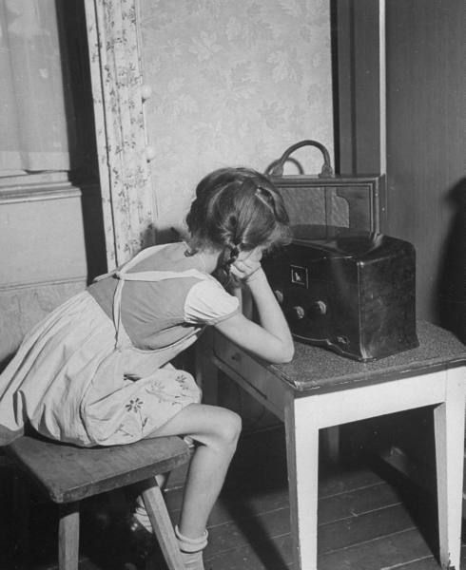**SUPPORT MATERIAL.**

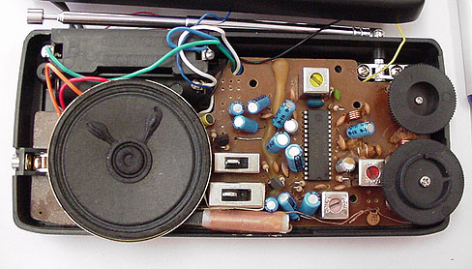Task.

1. As a physics student, which branch of physics help Akello in listening to the radio?
2. List any five items Akello saw when she opened the radio.
3. How was physics important to Akello in the scenario and our daily lives? (Give five).
4. Write down any four advice that you would give the parents of Akello.

Item two.

During the opening of a newly created swimming pool in Hoima city by the Hoima city mayor. The swimming pool manager said that the swimming pool measures 12m by 12m by 4m. The manager instructed the attendant during the session to fill the swimming pool up to 3.2m, it took 100 minutes to get full up to that height.

As the session was coming to an end, the city mayor, in order to open the swimming pool officially. He welcomed some members to come and swim. Ten members of masses 35kg,60kg,45kg,70kg,80kg,39kg,68kg,57kg,66kg,and 74kg jumped into the swimming pool and the level of water in the pool increased up to 3.8m. These made the attendant worried. That evening since the mayor was around, some two friends ask him for a house to rent for starting up a shop and the mayor accepted to give them the house. Amongst the items in their list missed items for measurements.

**SUPPORT MATERIAL:**



Task.

1. As a physics student, help the manager know;
2. The volume of the swimming pool
3. The volume of water before the ten people entered the swimming pool.
4. The density of the people that entered the swimming pool.
5. Help the manager understand the minutes in hours because many people would only understand hours than minutes.
6. As the physics student help the two friends with at least 5 instruments of measurements that they can use to open the shop.

Item three:

Mabaale town council is one of the town council suffering with the problem of unstable electricity each time it is about to rain. The government is alongside emphasizing diversification of our economy, in this Mr. John Charles Muswizi is having a shop and also practicing bee farming. He is one of the member suffering from unstable electricity. One day in the morning, after a night full of rains, lightning, and thunderstorm .Jane the daughter of John Charles came out and found one of their goat struck by lightning. Jane got worried but his brother ask her what state of matter could be lightning.

**SUPPORT MATERIALS:**

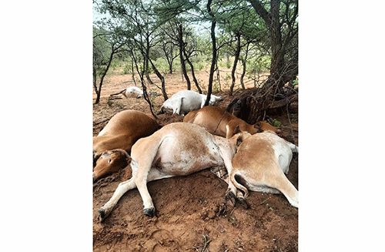Task:

As S1 student, help John Charles Muswizi solve his problem of electricity which is on and off always.

And what state of matter was lightning.

**THE END:**